# Spring Fundamentals Exam

# Shopping List Application

Exam for the "Spring Fundamentals" course @ SoftUni.

The **Shopping List** Application is here to help us keep in mind our shopping needs. The functionality is simple.   
When a user thinks of something important, they log in and add it to existing ones. So, when a person goes to   
the store, they have a clear idea of ​​exactly what to buy. So, our little app saves a lot of family scandals.

There are several requirements you must follow in the implementation:

## Database Requirements

The **Database** of the **Shopping List** application needs to support **3 entities**:

### User

* Has an **Id – UUID-string or Long**
* Has a Username (unique)
  + Username length must be between 3 and 20 characters (inclusive 3 and 20).
* Has a Password
  + Password length must be between 3 and 20 characters (inclusive 3 and 20).
* Has an Email
  + Must contains '@'.
  + Cannot be null.

### Product

* Has an **Id – UUID-string or Long**
* Has a Name (unique)
  + Name length must be between 3 and 20 characters (inclusive 3 and 20).
* Has a Description
  + Description min length must be minimum 5(inclusive) characters
* Has a Price
  + The price must be a positive number
* Has a Needed Before
  + Date and Time, that cannot be in the past
* Has a Category
  + Category cannot be null.

### Category

* Has an **Id** – **UUID-string or Long**
* Has a Name (unique)
  + an option between (Food, Drink, Household, Other)
* Has a Description

Implement the entities with the **correct data types** and implement **repositories** for them.

## Initialize categories

* Implement a method that checks (when the app started) if the database does not have categories and   
  initialize them
  + You are free to do it in different ways.

## Page Requirements

### Index Page (logged out user)

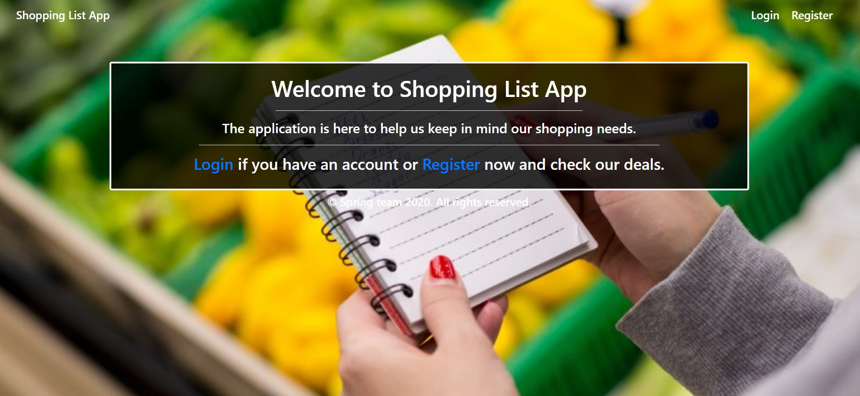

### Login Page (logged out user)

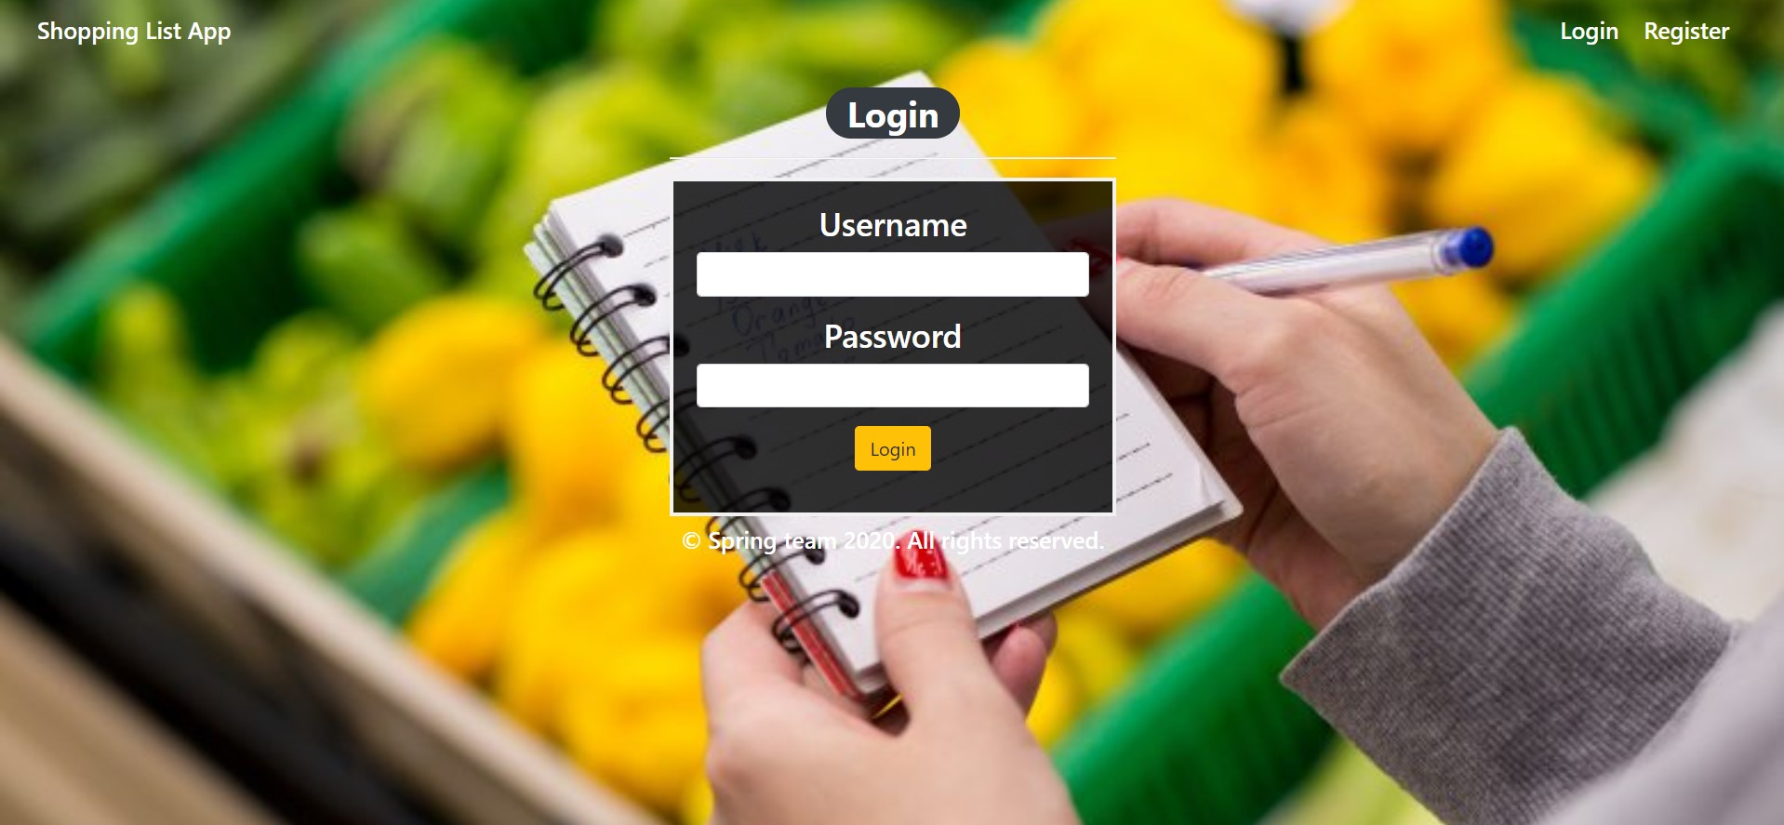

### Login Page validations

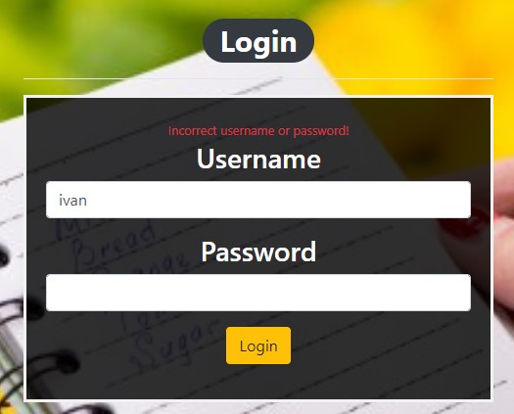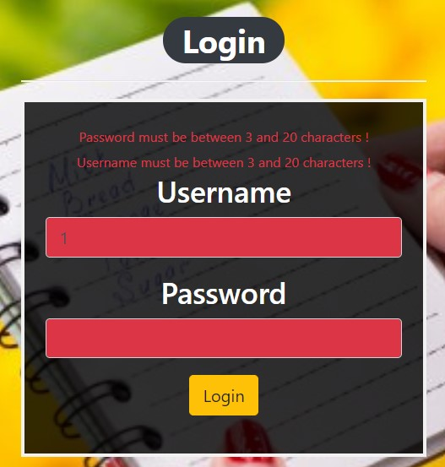

### Register Page (logged out user)

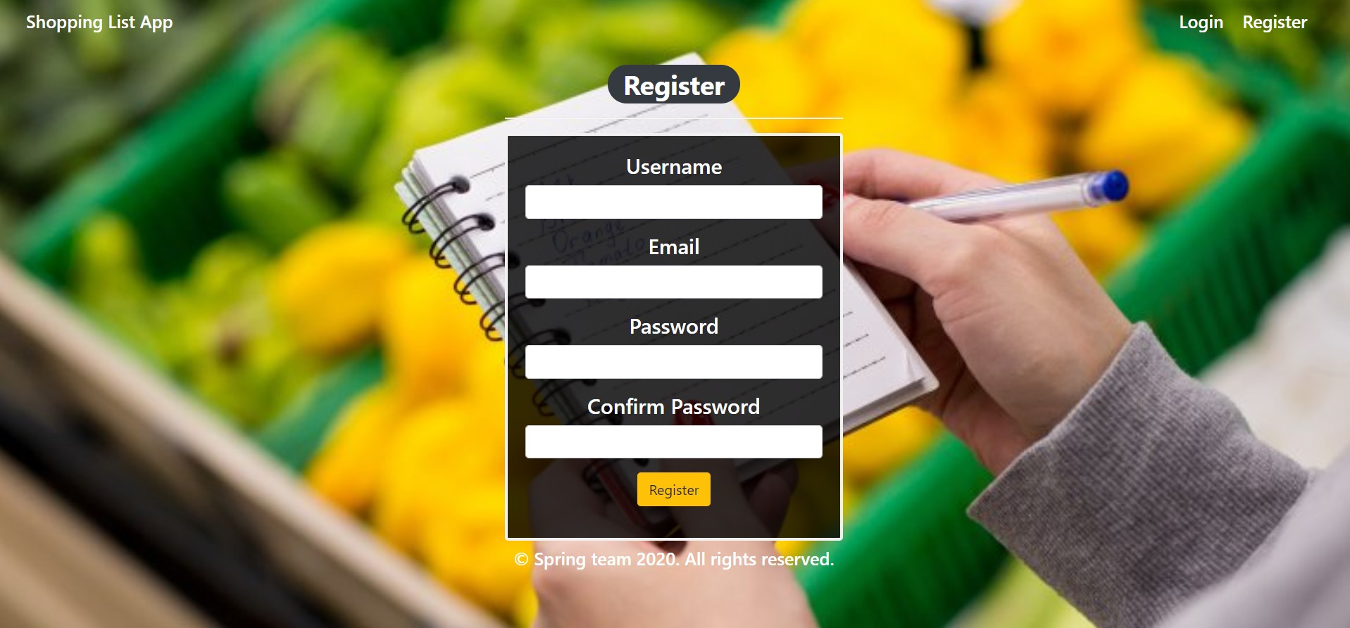

### Register Page validations

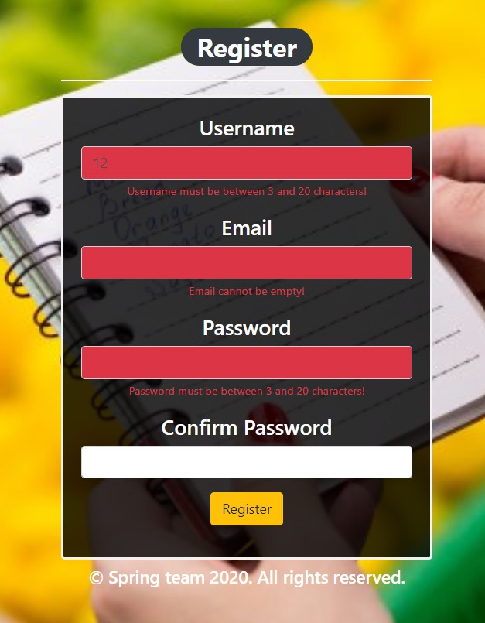

### Home Page (without having any products)

* Note: The home page should visualize **all of the products** from the database

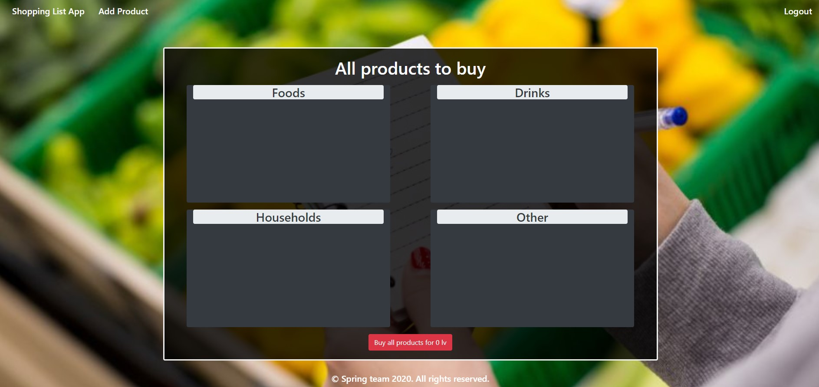

### Add products

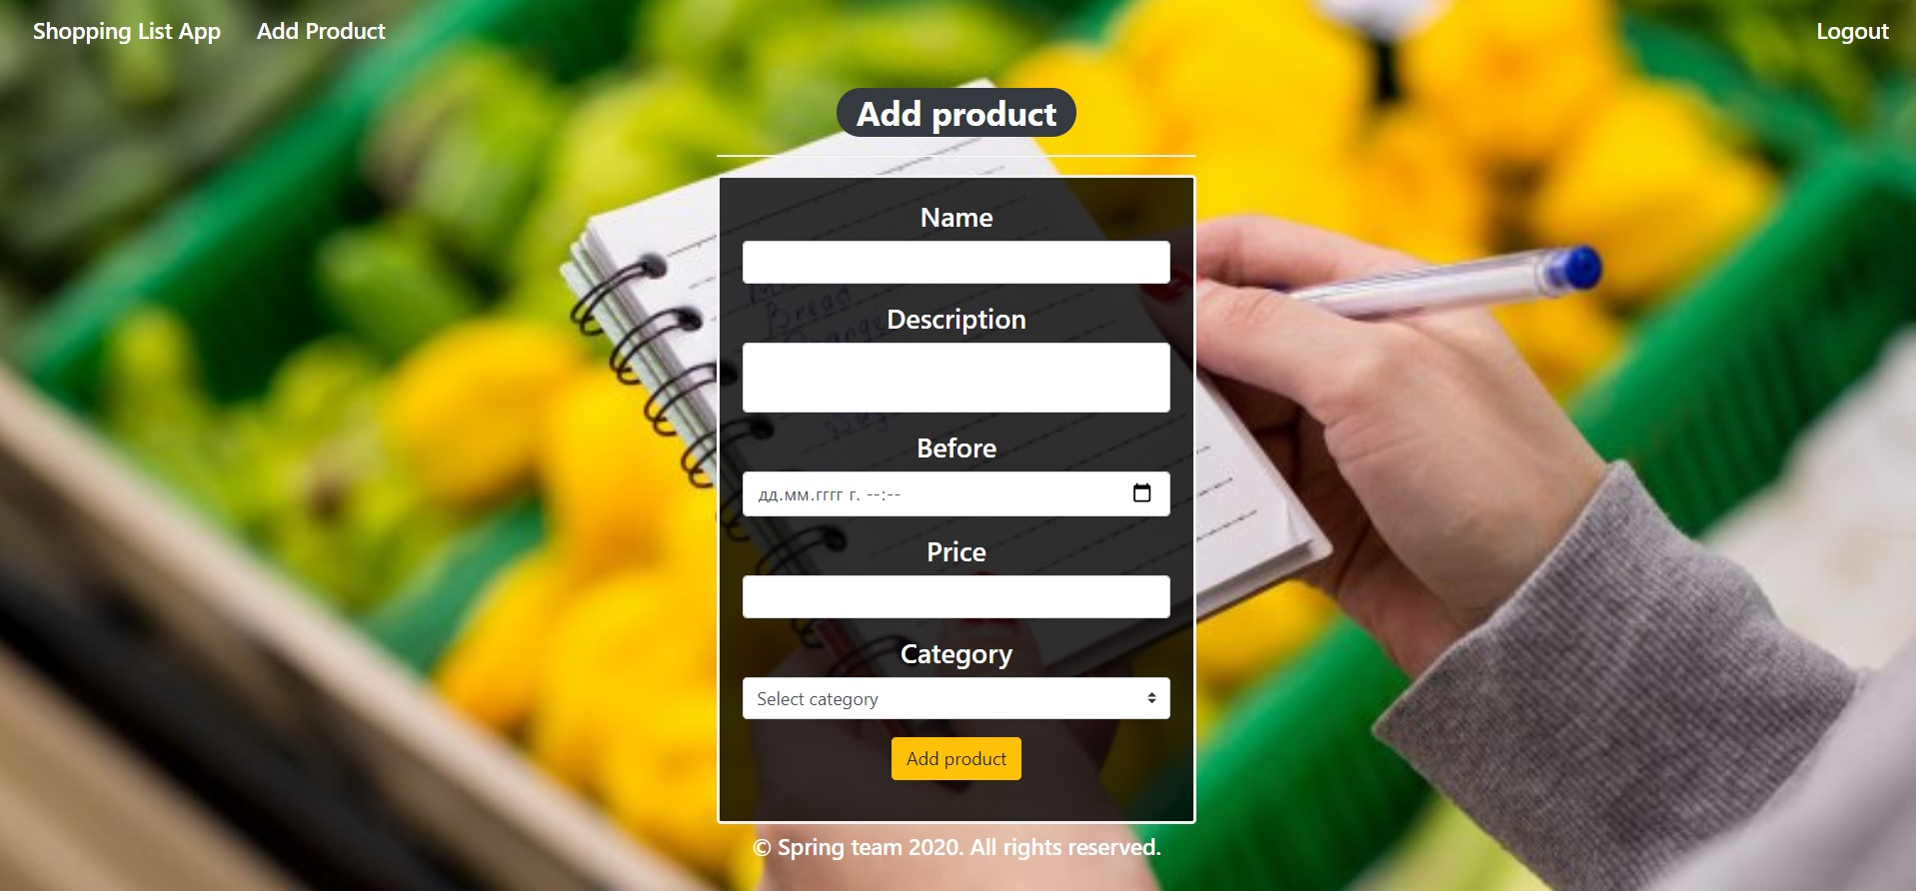

### Add products validation

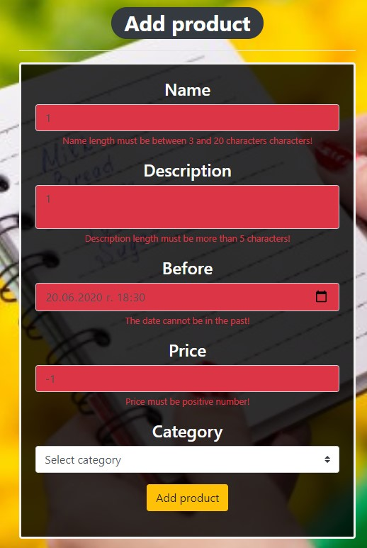

### Home Page (with products)

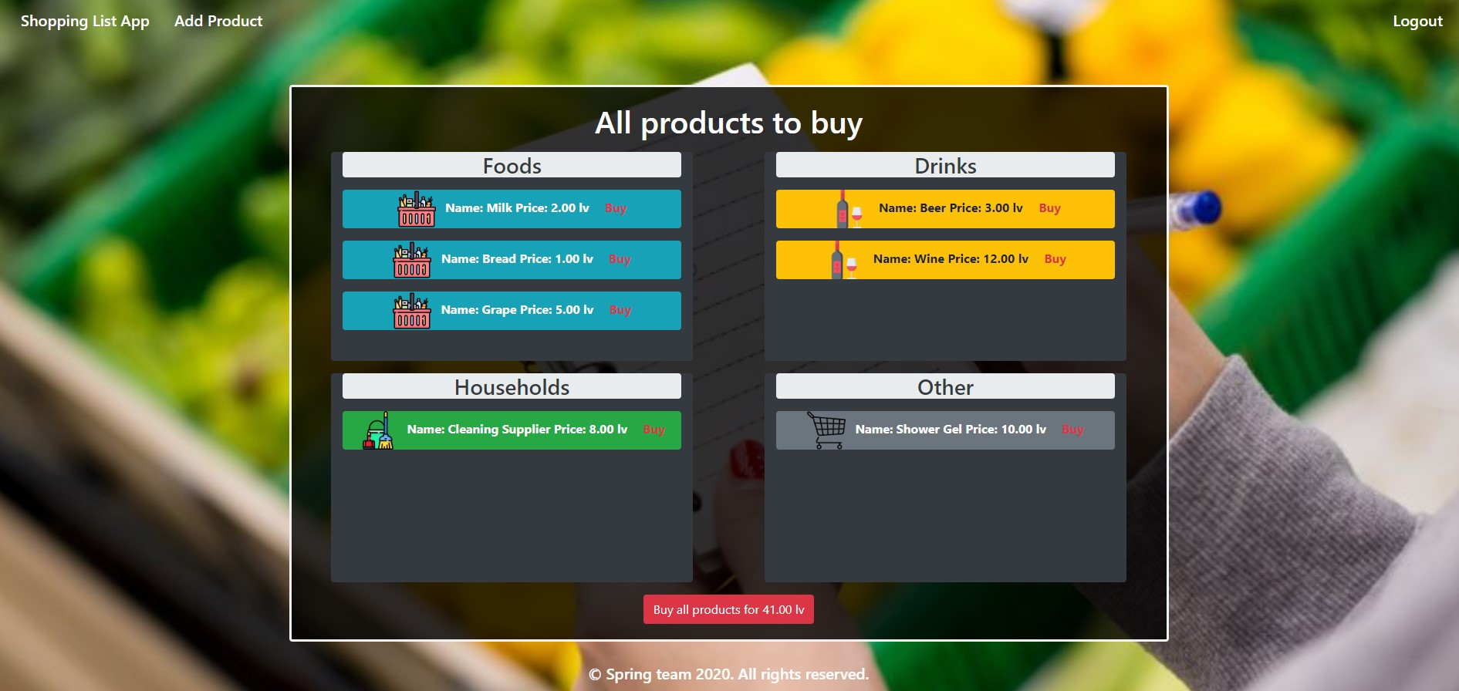

The templates have been given to you in the application skeleton, so make sure you implement the pages correctly.

**NOTE**: The templates should look **EXACTLY** as shown above.

**NOTE**: The templates do **NOT** **require** **additional** **CSS** for you to write. Only **bootstrap** and the **given css** are enough.

## Functional Requirements

The Functionality Requirements describe the functionality that the **application** must support.

The **application** should provide Guest (not logged in) users with the functionality to login, register and **view** the Index page.

The **application** should provide Users (logged in) with the functionality to logout, **add a Product**, **view all** Products (Home page) and **Buy a single one** from products **or Buy All** products.

**Shopping List App** in navbar should redirect to appropriate **URL depending** on that if the user is logged in.

The **application** should provide **functionality** for **adding products** with **category (**Food, Drink, Household or Other) and buying one or more of them.

The Buy all products button shows the sum of all added products prices.

The product should be separated into different divs according to their categories.

The **image** also depends on the item's category.

When the user clicks on the **Buy button** of some item, he buys it. You need to **delete** this **item** and **redirect it** to the **home** page. When he clicks on **Buy all** products, just **delete all** products in DB and again **redirect** to the **home** page.

The **application** should **store** its **data** in a MySQL database.

## Security Requirements

The Security Requirements are mainly access requirements. Configurations about which users can access specific functionalities and pages.

* Guest (not logged in) users can access Index page.
* Guest (not logged in) users can access Login page.
* Guest (not logged in) users can access Register page.
* Users (logged in) can access Home page.
* Users (logged in) can access Add Product page.
* Users (logged in) can access Logout functionality.

## Scoring

### Database – 10 points.

### Pages – 25 points.

### Functionality – 35 points.

### Security – 5 points.

### Validations – 15 points.

### Code Quality – 10 points.